**Geek Meet** is a social media platform for tech enthusiasts to connect, share posts, comment, like, and build profiles. Users, or "Geeks," can interact around shared interests, creating a community space for discussions and connections.

# Migration Files:

1. **create_geeks_table.php**: Migration file for the geeks table.

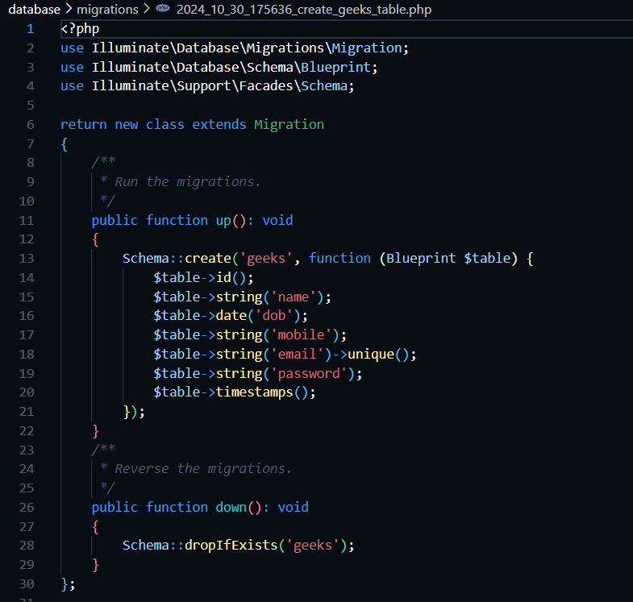

1. **create_profiles_table.php**: Migration file for the profiles table.

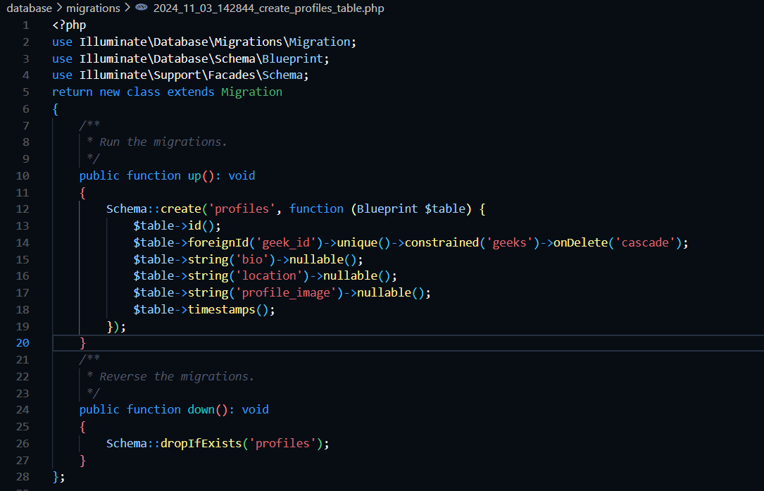

1. **create_posts_table.php**: Migration file for the posts table.

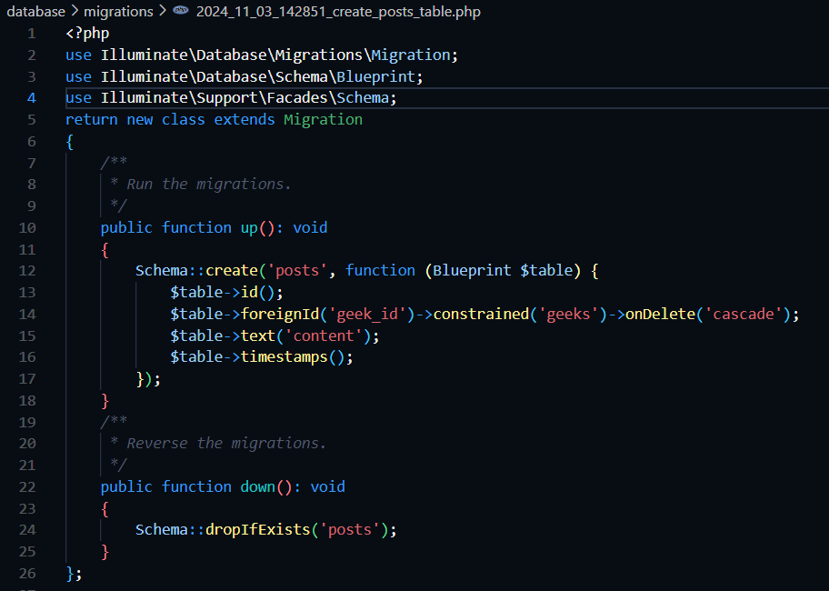

1. **create_comments_table.php**: Migration file for the comments table.

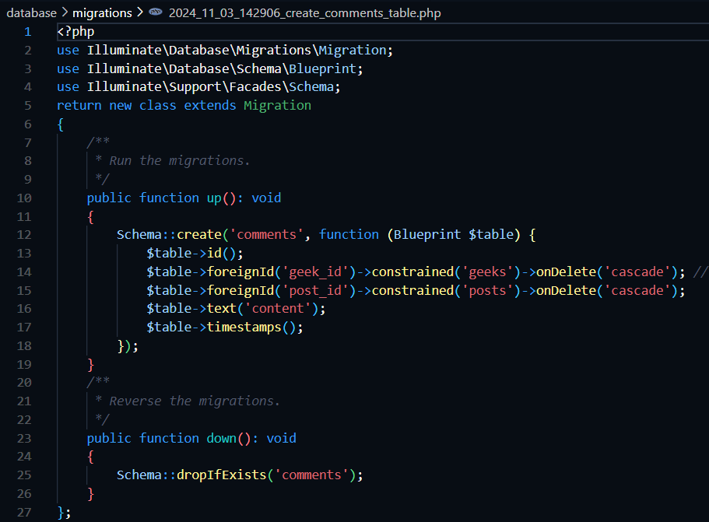

1. **create_likes_table.php**: Migration file for the likes table.

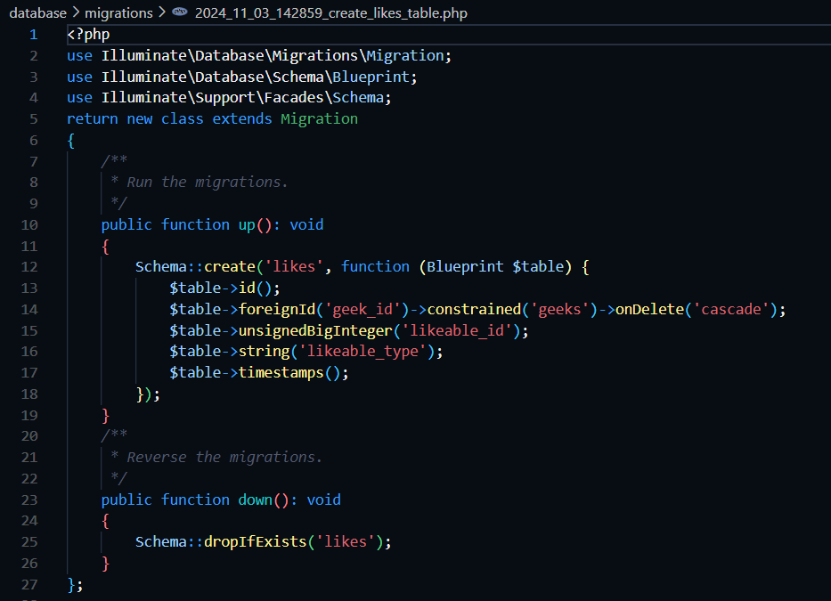

# Models:

1. **Geek.php:** Defines the Geek model representing a user in the application, with attributes like name, dob, email, mobile and associated relationships.

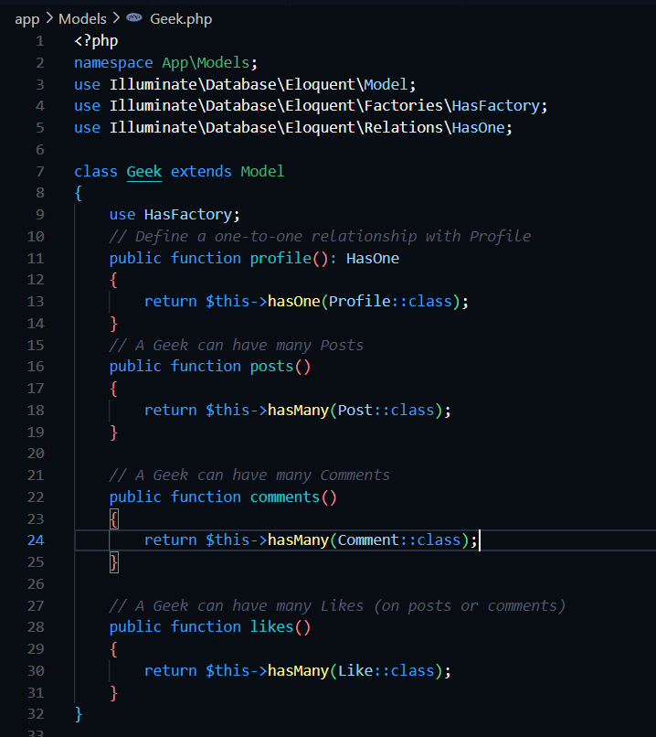

1. **Profile.php:** Represents user profile details in the application, linked to a Geek through a one-to-one relationship.

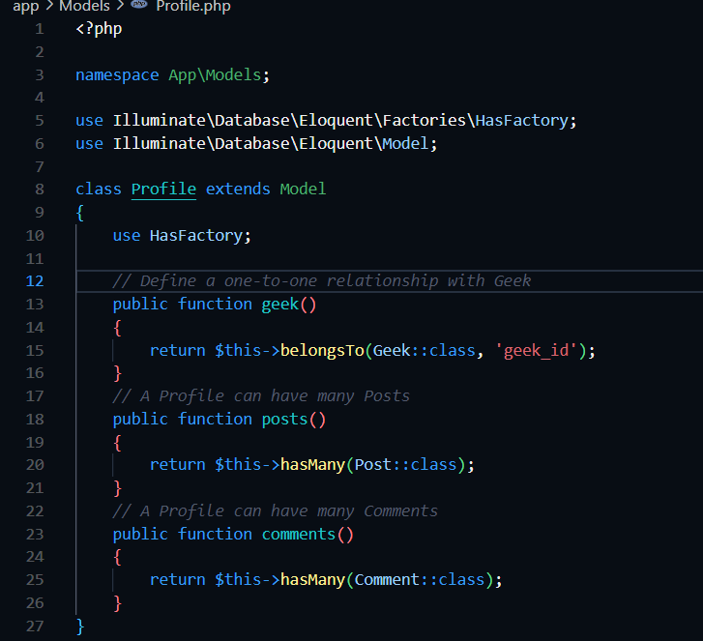

1. **Post.php:** Defines a Post model representing content shared by Geeks, with relationships to comments, likes, and the Geek who created it.

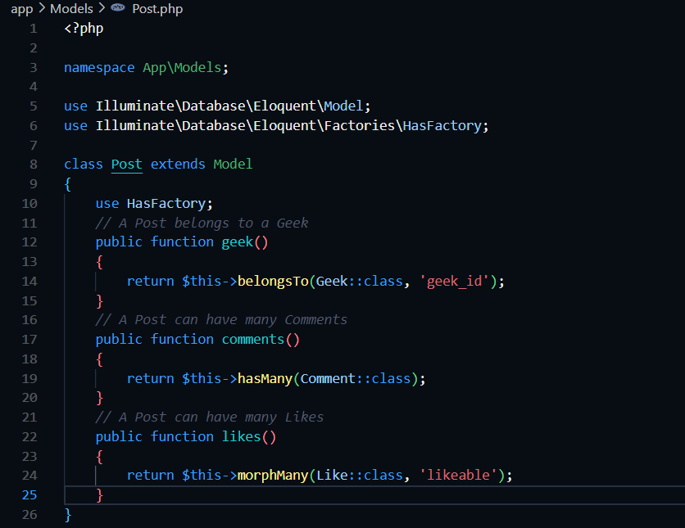

1. **Comment.php:** Represents comments made on posts, linking each comment to both a post and the commenting Geek.

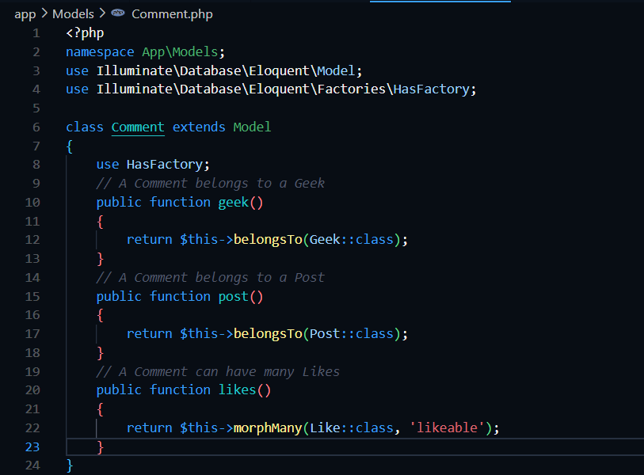

1. **Like.php:** Defines the Like model that allows Geeks to like posts or comments, supporting polymorphic relationships.

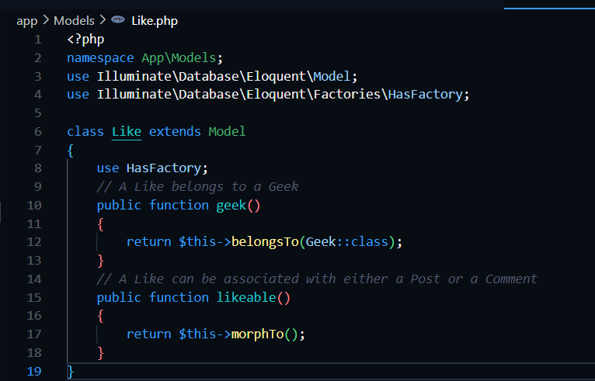

# Factories:

1. **GeekFactory.php:** Generates fake data for the Geek model, including unique emails, to facilitate testing and seeding.

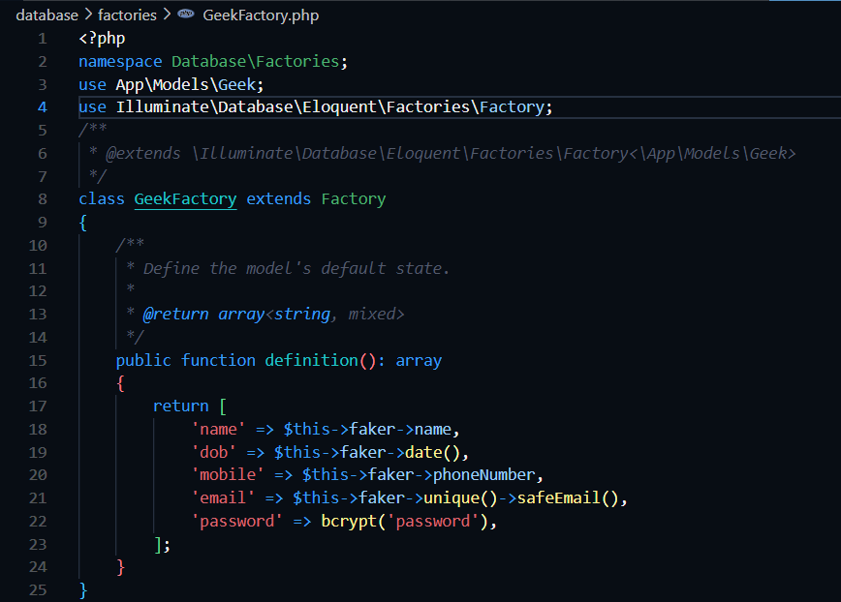

1. **ProfileFactory.php:** Creates dummy data for Profile instances, associating each with a unique Geek for testing.

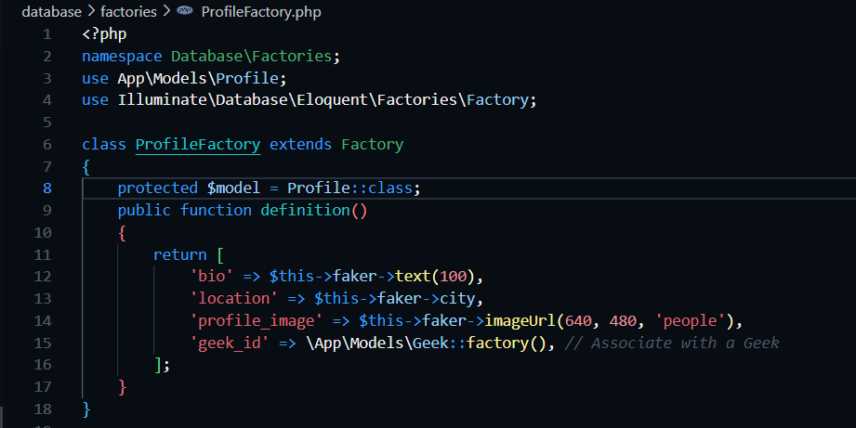

1. **PostFactory.php:** Generates test data for Post instances, associating each post with a Geek.

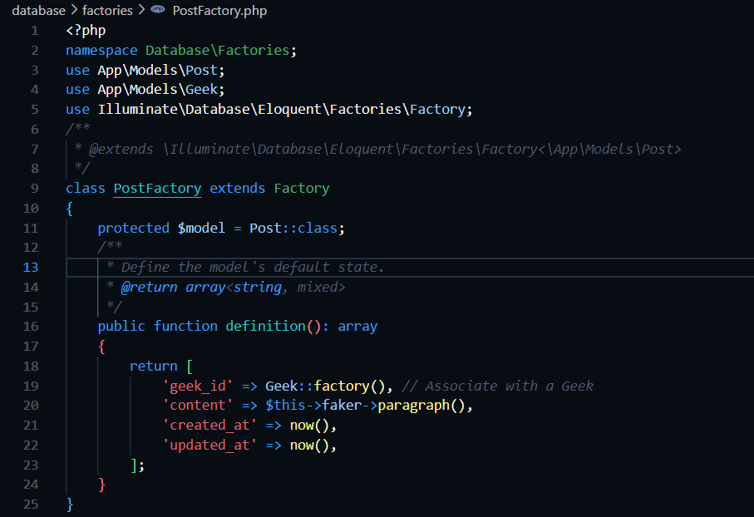

1. **CommentFactory.php:** Creates random comments for posts, each tied to a specific post and Geek, for testing interactions.

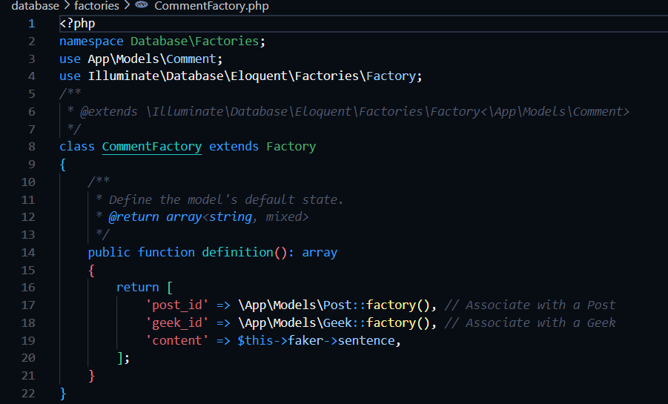

1. **LikeFactory.php:** Generates test data for likes on posts or comments, with polymorphic relations to support flexibility.

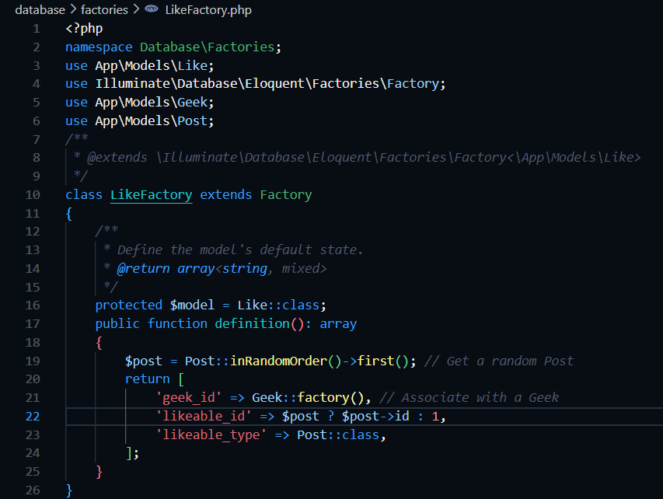

# Seeders:

1. **GeekTableSeeder.php:** Seeds the database with an initial Geek instance, manually setting attributes like name and email.

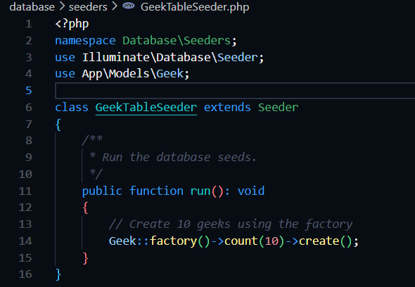

1. **ProfileTableSeeder.php:** Populates the database with Profile records, each linked to a specific Geek instance.

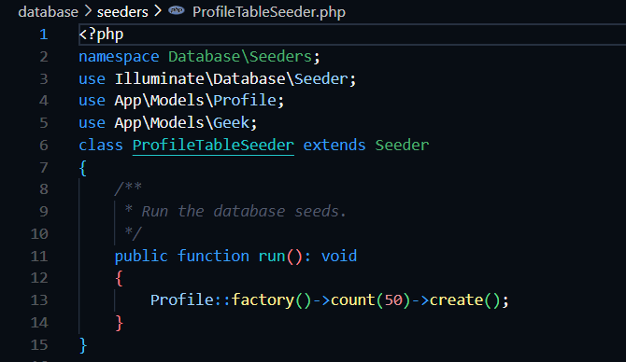

1. **PostTableSeeder.php:** Seeds posts in the database, associating each post with a specific Geek.

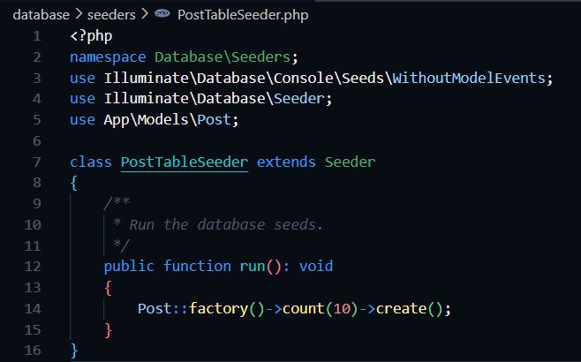

1. **CommentTableSeeder.php:** Add sample comments to posts, linking each comment to a Geek and a post.

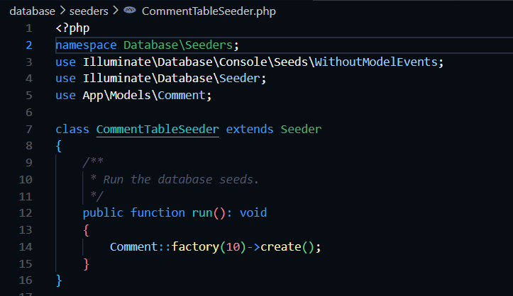

1. **LikeTableSeeder.php:** Inserts likes into the database, associating each like with a post or comment and a Geek.

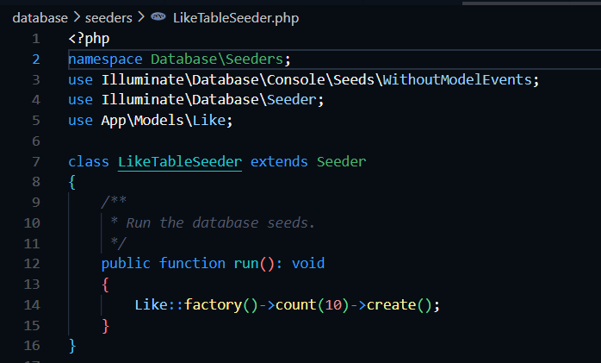

**DatabaseSeeder.php:** Coordinates the seeding of all models, calling individual seeders to populate the database with sample data for testing.

